**CURRICULUM VITAE**

* **CONTACT INFORMATION**

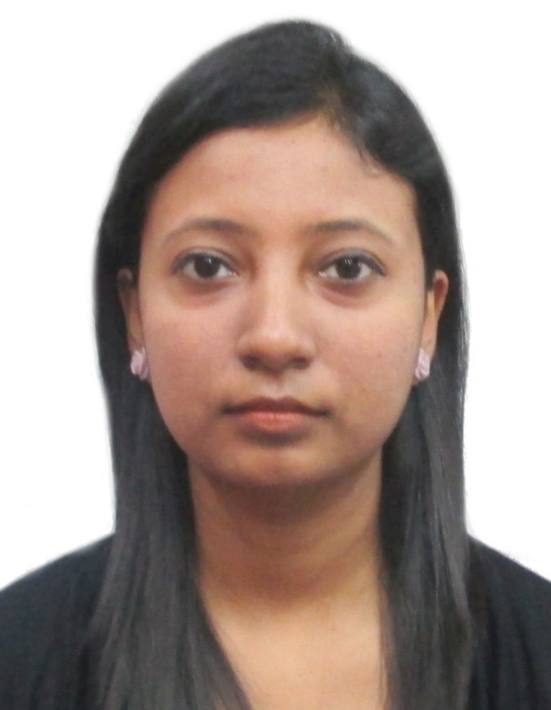

1. Full Name:- **Jhelum Sen**
2. Current Address:-

7/2, Bondel Road, Kolkata - 700019

1. Ph No.:- **9051754619**
2. Email Address:- mba.jhelum@gmail.com

* **CAREER OBJECTIVE**

I aspire to develop myself into a competent, reliable and responsible professional and grow with the organization in all respect. I do hope that my commitment and dedication towards my work will help the organization in facing new challenges and attaining higher goals to go forward.

* **EDUCATION QUALIFICATION :**

|  |  |  |  |  |
| --- | --- | --- | --- | --- |
| **Board** | **(Percentage of Marks)** | **Division** | **Stream** | **Year** |
| PTU | 74.14% | 1st | MBA-Marketing | 2011 |
| BA | 76% | 1st | Travel & Tourism Management | 2007 |
| WBBHSE | 59.4% | 2nd | Science | 2003 |
| WBBSE | 76% | 1st |  | 2001 |

* **Extra Qualification:**

* Certificate course on Travel and Tourism Management from Global Travel Xperts Academy
* Aussie Specialist Certification on Destination Management Programme.

* **Technical Skill**
* MS Office
* Proficient in SABRE/ Amadeus
* **Job Experience:**
* Presently working in The Transworld as Travel Consultant from July 2016.
* Worked as Asst. Sales Manager in Maruti - Mohan Motor Udyog from 2011- 2015
* **Personal Information**

1. Date Of Birth:- 19/06/1984
2. Nationality:- Indian
3. Gender:- Female
4. Marital Status:- Single
5. Language: English,Hindi, Bengali

* **Key Skills**
* To understand properly the customer preference
* To know properly the tourism destination in India and abroad

* **Hobbies**
* Love to travel around the world.
* Dancing

**I, do here by declare that all the above statements given by me is true and correct to the best of my knowledge.**

**Date: ……………..**

**Jhelum Sen**

**Signature:……………………**